RMCCT Weekly Check-In April 22, 2020
12 participants
Check-In:
- Susan/EY MCFD; Not a lot to update, things starting to settle – all service lines figuring out how to provide service. Sending out flyers of beneficial info. Doing an update for staff about resources that I’ll send out to everyone.
- Nikki/Family Ed; put together workshops that will be happening. Conflict resolution for parenting, Parenting resilient children, Home Alone. Will talk to each participant to make sure they’re set up on zoom, etc. Only 10 participants. Other programs as well have been going on. Boxes for participants’ houses, activities, etc. Touching base with partners to let them know what’s going on.
- Christina/CN; had another facilitator meeting, talked about what’s going on. Seems like things are settling in through the innovation part of the covid phase, just need to do it all now. So many organizations doing an amazing job getting things done, many great opportunities to provide service.
- Naomi/ACT; we have just launched virtual learning program starting next week. We have theatre, art, acting classes going on – there is a charge for them. If there are people that need help financially contact us, we may be able to help. We’d like feedback to know how we’re doing. We’re continuing offsite with limited staff, trying to make plans, working out what summer and fall will look like. 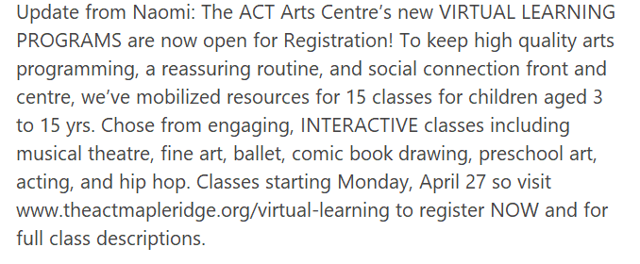
- Melanie/ SD ; Things are going well, Strong Starts up and running on line. Looking at vulnerable students, will take time.
- Helen/Healthy Babies; started zoom groups this week, healthy babies. A few referrals from places, interesting to call back saying to join zoom groups. It all feels strange for everyone, figuring out how to navigate this with new participants, etc. Doing deliveries out in Tri-Cities and Maple Ridge areas. Do we do groups every week? Every other week? 1 week go and do deliveries? We’d like to do some meals as well since we had a lunch program. Little ideas going around. It feels busier working like this rather than going to work. Getting little self care bags made up for Moms around Mother’s Day.
- Drea/SD ; Just back from medical leave, just getting caught up and to see what my role is. My job is afterschool programs but there’s no school. Cancelling programs, working with facilitators on how do some online programming. Creating document for parents with all free online programs for kids on how to keep them busy. Parents struggling with mental health, organization, structure, I want to help them in anyway we can. Trying to do as many free as possible. Exercise programs happening; karate, yoga, etc. Planning on how to move forward, can we offer program in schools with limited numbers. Social distancing from adults is hard for kids, how do we keep everyone safe. If you have anything, you’d like me to add to our resources information please send it to me.
- Virginia/Pivot Point ; If any students you’re supporting are using autism dollars we are still open. We are doing sessions mostly video, we have had authorization to do in person session if we can guarantee safety. Still doing what we can do. Offering free programs, will get details and send it out to Drea. Looking at ways to support parents, we also have counsellors very familiar with doing online counselling. Families that were on waitlists, now is a good time to reach out. Very community minded, we want to help. We are online everywhere as well if there’s anything you want us to pass on to families.
- Jennifer B/City of Maple Ridge ; 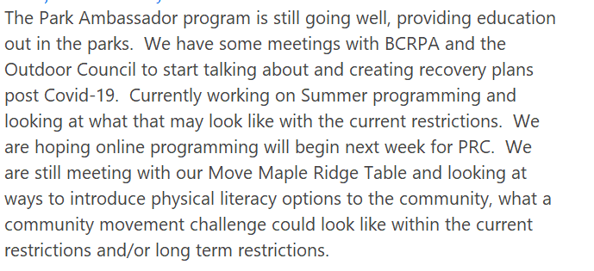
- Shawn/RMCDC ; We’re still operating doing a lot of stuff virtually, intake meetings and transition meetings with school district. New referrals a little more difficult to do through virtual platform. Working a lot with IDP and other community partners.
- Natalie/Family Nav ; Connecting with families has continued. Posting different resources, if you have any programs/posters, please email them to me. Working on care packages for some families. Family Leaf drop in going well, other programs going well, well attended. *one concern I have is getting a particular family connected with zoom and Facebook, they have very limited English – trying to explain instructions on how to help them do this (Chinese speaking). Trying to get translated instructions so they can get on zoom and Facebook. – Jenny; I suggest you contact Danielle and ask if any of the volunteers are able to do translation – also Carolina. Virginia – make sure you know for sure what language they speak.
- Ginna/FRIS ; We are looking at adjusting some of our funding we get, understand that access to internet etc., is not an even distribution to our families. Have put forward for a grant to purchase items, wondering if access for tablets is going forward. What kind of device is best? Would like to purchase what SD’s, etc are already using. Headsets are always sold out, that’s an issue. If you know of any place to get some, please let me know.
- Wendy/RMCDC ; Not too many changes from last week, staff still working on ways to connect with family. IDP finding it easier than the SDC programs. Lots of training happening. I like to hear what others are doing for ideas.
Emerging Issues & Gaps;
- Jenny; food and basic needs; there may be some families(ages 0-6) that are falling through the cracks that may not get captures through school district or accessed the Salvation army food program before this, might be having a problem putting food on the table. Family Ed is looking at this. Is there a need for a more focused conversation for this, collaboration? Thoughts? Issue? Not Issue?
  - Wendy; I do think there are some that fall through the cracks. We gave a gift card to a family that doesn’t qualify for anything but can’t pay the rent this month. I’m not sure how to reach them or find out.
  - Jenny; I could reach out to agencies that I know that are providing this to see if we can work together to make it know to young families with children that this is available if they need it.
  - Wendy; could you put something in the newspaper?
  - Jenny; good idea, I’ll reach out to you and other agencies to see who is providing food resources for families 0-6 and if there is a way that we can make sure those families are not getting missed.
  - Susan; check with Brenna on that as well, she’s pulling together a food resource list, Ginna as well.
- Drea; I’m aware that parents are overwhelmed with papers, flyers, phone calls, etc. Do you think it’s a good idea for us to send something out? Have they already received a lot of this?
  - Jenny; online is good, drop box, etc.
  - Susan; I think parents were feeling overwhelmed last week or so with school coming online, etc. I sense this week that things are settling now, people are able to read emails, etc. Still good to send something to let them know there is no pressure but there are resources available. They may have got all the info but lost in the shuffle and no time to have read it earlier. It’s up to them to click on it, they don’t have to. I would air on the side of doing it.
  - Helen; someone may not have needed it 3 weeks ago but may need it now.
  - Jenny; I’d much rather hear that they had too many emails rather than that they didn’t know what to do. We should pace it out.
  - Drea; mind would be tailored to online activities for kids. I’ll send it out to you as well if you want to use it.
  - Christina & Susan; send it to me too
Email distribution List;
- Jenny; I said I was going to do it and then have someone take it over. Email; reg@familyed.ca - I have 2 people that will be doing this now. Send anything to this email that you’d like distributed to the entire table. We’ll redistribute everything that comes in as long as it doesn’t look suspicious.
Facebook Page;
- Jenny; Children’s table has it’s on Facebook page, we have permissions to get in to that page. Is there anyone that would like to volunteer to take this on? Let me know or I will see if someone at family ed will do it.
Anything for next Agenda;
- Susan; for post covid – could we look at our plan and see how we will be moving forward. Have a look at our plan, our priorities, etc. Revisit it, what is realistic in terms of communications, etc.
- Jenny; are we happy with the current format? – no answers
Meeting frequency;
- Jenny; we’re now at the 3rd week of the month. Do we continue weekly? Every 2 weeks? Etc.
- Christina; I think it’s valuable to do once a week even if it’s shorter. I always go away with good information.
- Drea; I agree, super informative and helpful. Everything has been changing so quickly. I feel that if we waited 2 weeks we may miss something.
- Susan; I do have it booked weekly until May 13, maybe we can revisit it at that meeting.

Meeting adjourned at 1:57pm

