Ridge Meadows Community Children’s Table

Meeting Notes

April 29, 2020

1:00 p.m.
Type of Meeting: Via Zoom
18 participants
Meeting Facilitator: Susan Foster
- Check-in (round)
- Christina/CN: If there’s anything you want in the “What’s Happening” please send them to me.
- Jo-Anne/CCRR: Doing what we can for clients and staff. Doing busy bags, parents loving them. Clients pre-register with names/ages of children. Every 2 weeks. Workshop with care providers, doing it through zoom.
- Drea/SD: Creating an online resource library for the care providers for essential workers, will be on district website. Looking for YouTube links, videos, etc. District will have a tab open for public for parents to access. A part up PM Covid-19 task force, how to reach most vulnerable population in PM. Information will go out to the community and is on PM website.
  - Melanie; will send YouTube videos to help out
  - Jo-Anne; Strong start facilitators have a lot of info as well
- Helen/Healthy Babies: Groups having good turnouts, new referrals coming in. Welcome package, pre-natal, zoom instruction on completing registrations. Finding pros and cons to joining this way. Told to hold off on sending out meals for now. Getting things together to deliver for Mother’s Day.
- Jackie/PM; Covid 19 Task Force - Revision of terms of reference to be more inclusive. Meetings with community service to find out what support is out there, how to reach people, how do they access services, etc. Doing up a postcard identifying partnership with community services phone number. Looking at a longer term how to support and identify. Main direction to promote community services. Creating resource guide, how to service existing members and reach out to new people, grass roots information for community. Making sure website is accessible and clear with so much information coming out. Will share postcard and info with RMCCT. Also; what will services look like when approval to open up, implementing programs but being safe for people. Not sure what will happen with fitness centres, also working on formula for youth Centre.
- Jen Baillie/City of MR; 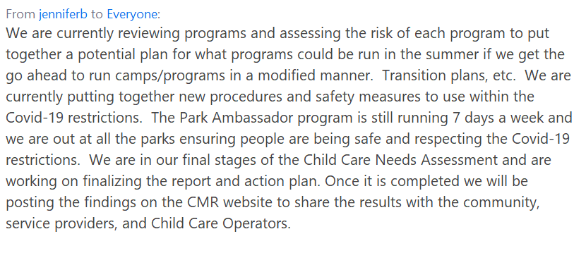
- Nikki/Family Ed: 5th week of boxes for afterschool program, going well. 2nd wave of postcards going out. More room for families in need to join the program. Still doing free workshops for parenting.
- Natalie/Family Ed: Still posting on Facebook and Instagram; resources and activities. Delivering needs to families. Family Leaf has also put together craft packages to be going out.
- Jenny/Family Ed: Family Ed and Tri-Cities family place working together with Mother Goose. Family Ed collecting homemade cloth masks and food items to provide support for temp foreign workers.
- John/RMACL: Continuing to roll out funding to essential service workers for families with in home daycare. CYSN has approved respite families to receive direct funding where otherwise receiving services, working on this. Issues; families with more than 1 child with needs, majority of respite providers are not providing right now. If anyone knows of people that might be willing to provide social distancing respite please contact us. Families with children with needs, not eligible for services yet due to no assessments; looking at trying to support them in some way. Families where parents may have health needs that are trying to support children with needs at home.
- Wendy/RMACL: IDP – consultants doing video chats with families; they’re opening up more, wanting the consultations now more. SCD – doing a lot of Kindergarten transition meetings lately. Starting to see families return kids to daycare. Balancing kids returning to centres, kids who qualify for support, staffing ratio is an issue. Checking in on these situations. Indigenous programs doing more hands on, creating activity packages for their families.
- Kerry/FSIBC: Following Dr.Henry’s guidelines around hospital admitting, etc. Doing theme zooms.
- Liza/library: Have the e-card now, videos online for families. Waiting to see what transitioning back looks like. Staff continuing with online program creation. Had an article in Maple Ridge news I can share with you. (all resources you can get from the Library online)
- Melanie/SD: working on welcome to K with workable solutions we can have for schools. Consistent approach for continuity across district. Hoping to send district wide Early Learning newsletter. K transition meetings happening constantly. Working on vulnerable students and how they can support those families; in the hub or different way.
- Lori/ACT: started some of the 15 virtual classes this week, registration is good. Working on summer programs and what will it look like, waiting for guidance.
- Fraser Health: Linda via email: Immunization clinics are busy. Brenna: Covid testing has opened up more, encouraging people to go through self-assessment on website. Encouraging more testing in community outbreaks. Websites are updated with current information.
- Susan/MCFD: interesting statistic there have been 76 home visits in terms of child protection in the last 10 days in North Fraser; SW’s still going into homes and doing assessment for child safety. CYMH services have come up with creative ideas how to work with families, continuing to see families.
- Question from Jenn;
- 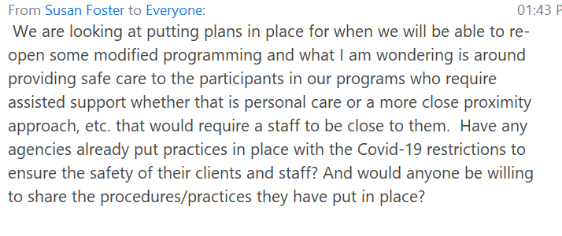Melanie; the SD is working on that, same situation, will connect you with people to talk to.

- Business Arising
  - Food Security
    - Brenna; food banks and food program organizations are meeting on Friday to discuss and update opportunities for collaboration and gaps in service.
    - Drea; concern – families that the SD are supporting right now – how are we ensuring we’re connecting them to resources once summer hits. Working on this. Brenna: a flyer has gone out with all resources and gone out to all families receiving from school district right now.
  - Back to School Coping – no comments on this
  - Facebook Page
    - Working on the details of the account itself. We have 2 volunteers willing to manage the Facebook page.

- New Business
  - Surveys Burnaby is doing
    - Susan: suggested the other 3 communities may want to do the survey and we can compile all info individually and as a district. Would like the same survey for all communities. Would like to form a working group and partner with Tri-cities. (Susan went through the survey). Any initial thoughts (parent survey)?
      - Jenny and others: fabulous idea, very useful feedback
      - Jo-Anne: not sure about “what practical help do they need. Would they expect us to do what they suggest?
    - Any initial thoughts (service care provider)?
      - Brenna; with both, looking at what we’re going to use the findings for. Is it going to change anything we’re doing now? Lots of surveys going out right now, lots of impact surveys. If we are going to use the data to help improve service to clients then great.
      - Susan; service providers were making assumption on what families need so this is one of the reasons the group decided to do this. Agree with using it not just doing it.
      - Jenny; in some cases, services have been re-written and designed with a lot of assumptions, it will be helpful for us to ask parents / providers. Agree in not overwhelming people.
*Any volunteers to work with Susan on this? – Kerry, Natalie, Christina

  - RMCTT Covid Page on Website?
    - Susan: I sent out a list, wondering about posting something on the website around this?
      - Drea; sent to SD communication department and they included all links on their Covid portion of website. Will be part of the resources compiled to go home to students.
      - Susan: will update links and send them out to all
  - Work Plan Areas to Review (Will table until next meeting – no time)
    - Communication strategies for promoting programs, workshops, training etc. – doing this already
    - Messaging regarding resiliency – not sure how we can go ahead with them now
    - Promoting play
    - Children’s Charter
  - Dialogue/Sharing Session on Virtual Platforms – is there interest? Expertise?
    - Thinking of pulling together a session around this (all of North Fraser) to share tips/tricks. If anyone has expertise or wants to share please let me know.

Meeting adjourned 2:04pm Next Meeting – May 6 @ 1:00 p.m.

